**LZ77**

**1-Tag class**

* pos - Position of the matching substring in the search buffer.
* len - Length of the matched substring.
* lastChar - The next character after the match.
* The toString() method formats the tag as <pos, len, lastChar>.

**LZ77 Class**

**Compression Method**

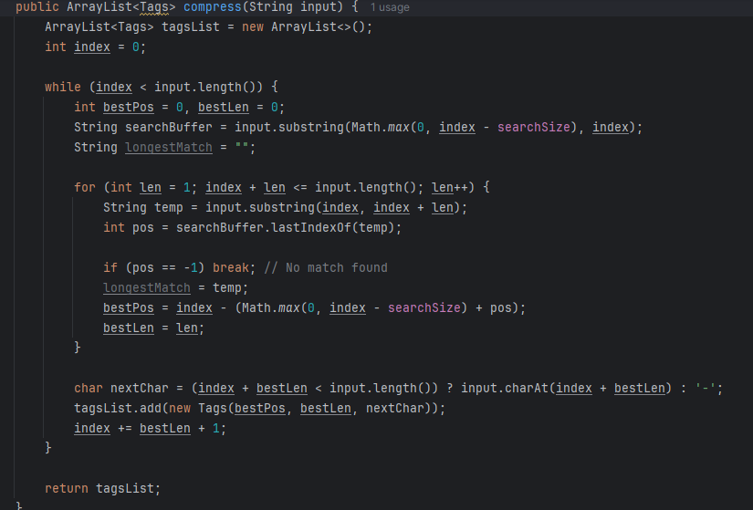

* **Uses a sliding window approach with a search buffer of size 10.**
* **Finds the longest match in the search buffer.**
* **Stores match position, length, and next character in a list of Tags.**
* **If no match is found, it stores <0,0,nextChar>.**
* **Increments the index based on the length of the match found.**

**Example:**

**Input.txt**



**Output.txt**

**Example 2:**

**output.txt**

**Decompress**

* **Iterates through the list of Tags.**
* **Uses position and length values to reconstruct substrings.**
* **Appends the reconstructed data to form the original text.**

**Example 2**

**Decompress.txt**

**Main class**

**The user provide the input file for compression and decompression then the output file is saved.**

